SUMO Structure

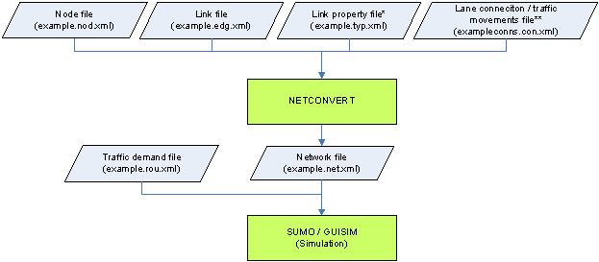

SUMO Documentation - <http://sumo.dlr.de/wiki/SUMO_User_Documentation>

TraCI

TraCI is the short term for "**Tra**ffic **C**ontrol **I**nterface". Giving the access to a running road traffic simulation, it allows to retrieve values of simulated objects and to manipulate their behaviour "on-line".

## Using TraCI

### SUMO startup

TraCI uses a TCP based client/server architecture to provide access to [SUMO](http://sumo.dlr.de/wiki/SUMO). Thereby, [SUMO](http://sumo.dlr.de/wiki/SUMO) acts as server that is started with additional command-line options: **--remote-port** [***<INT>***](http://sumo.dlr.de/wiki/Basics/Notation#Referenced_Data_Types) where [***<INT>***](http://sumo.dlr.de/wiki/Basics/Notation#Referenced_Data_Types) is the port [SUMO](http://sumo.dlr.de/wiki/SUMO) will listen on for incoming connections.

When started with the **--remote-port** [***<INT>***](http://sumo.dlr.de/wiki/Basics/Notation#Referenced_Data_Types) option, [SUMO](http://sumo.dlr.de/wiki/SUMO) only prepares the simulation and waits for an external application, that takes over the control. Please note, that the **--end** [***<TIME>***](http://sumo.dlr.de/wiki/Basics/Notation#Referenced_Data_Types) option is ignored when [SUMO](http://sumo.dlr.de/wiki/SUMO) runs as a TraCI server, [SUMO](http://sumo.dlr.de/wiki/SUMO) runs until the client demands a simulation end.

When using [SUMO-GUI](http://sumo.dlr.de/wiki/SUMO-GUI) as a server, the simulation must either be started by using the [*play* button](http://sumo.dlr.de/wiki/SUMO-GUI#Usage_Description) or by setting the option **--start** before TraCI commands will be processed.

TRACI Documentation - <http://sumo.dlr.de/wiki/TraCI>

## TraCI4J

TraCI4J is a Java library for interfacing [SUMO](http://sumo.sourceforge.net/) with a Java program to control and/or watch a traffic simulation via SUMO's [TraCI](http://sumo-sim.org/userdoc/TraCI.html) interface.

It was initially developed by members at [ApPeAL (Applied Pervasive Architectures Lab)](http://www.dauin.polito.it/it/la_ricerca/gruppi_di_ricerca/appeal_applied_pervasive_architectures_lab) in [Politecnico di Torino](http://www.polito.it/).

## What can TraCI4J do

The library can act as a complete front-end for a SUMO instance. The simulation can be started, stopped and advanced step by step.

The SUMO instance can be run by the library itself or can be already running. Since the TraCI communication is done via TCP, the existing SUMO instance can be in the same machine or in another host.

While the simulation is running, many informations can be retrieved, both static (e.g. the road network topology) and dynamic (e.g. position and speed of vehicles). A set of TraCI4J classes match the corresponding [TraCI objects](http://www.polito.it/), each with methods that allow for value reading and state changing.

TRACI4J API - <http://sumo.dlr.de/daily/javadoc/traci4j/>